Q10 Hobby

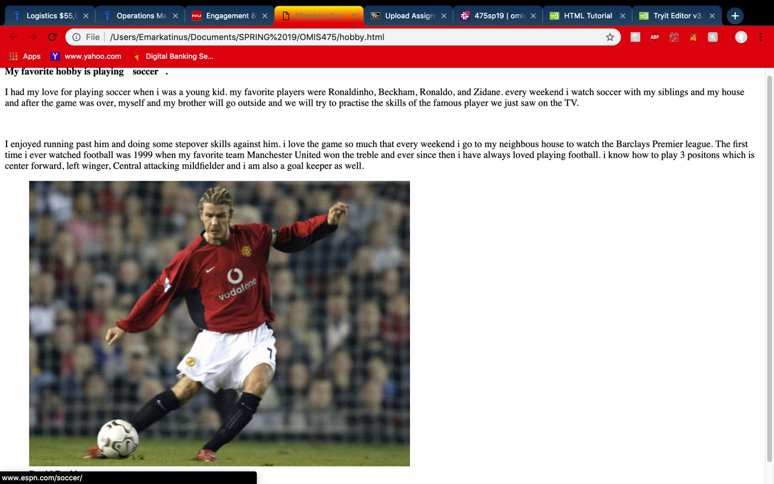

<file:///Users/Emarkatinus/Documents/SPRING%2019/OMIS475/hobby.html>

<!DOCTYPE html>

<html>

<head>

<title> Efetobo's Favorite Websites </title>

<style>

body {

background-color: white;

color: black;

}

a:hover {

text-decoration: none;

padding: 11px;

color: white;

}

a:visited {

text-decoration: none;

color: red;

}

a:link {

color: black;

}

header {

font-weight: bold;

}

</style>

</head>

<body>

<div>

<header> My favorite hobby is playing <a href="http://www.espn.com/soccer/">soccer</a>.</header>

<main>

<p> I had my love for playing soccer when i was a young kid.

my favorite players were Ronaldinho, Beckham, Ronaldo, and Zidane.

every weekend i watch soccer with my siblings and my house and after

the game was over, myself and my brother will go outside and we will

try to practise the skills of the famous player we just saw on the TV.</p><br>

<p> I enjoyed running past him and doing some stepover skills against him.

i love the game so much that every weekend i go to my neighbous house

to watch the Barclays Premier league. The first time i ever watched

football was 1999 when my favorite team Manchester United won the treble

and ever since then i have always loved playing football. i know how

to play 3 positons which is center forward, left winger, Central attacking

mildfielder and i am also a goal keeper as well.</p>

<figure>

<img src="David Beckham.jpeg" alt="Beckham">

<figcaption>David Beckham</figcaption>

</figure>

</main>

<footer>

<a href="mailto:efetobooraka@yahoo.com">efetobooraka</a>

</footer>

</body>

</html>

Q8 & Q9

My links

<file:///Users/Emarkatinus/Documents/SPRING%2019/OMIS475/mylinks.html>

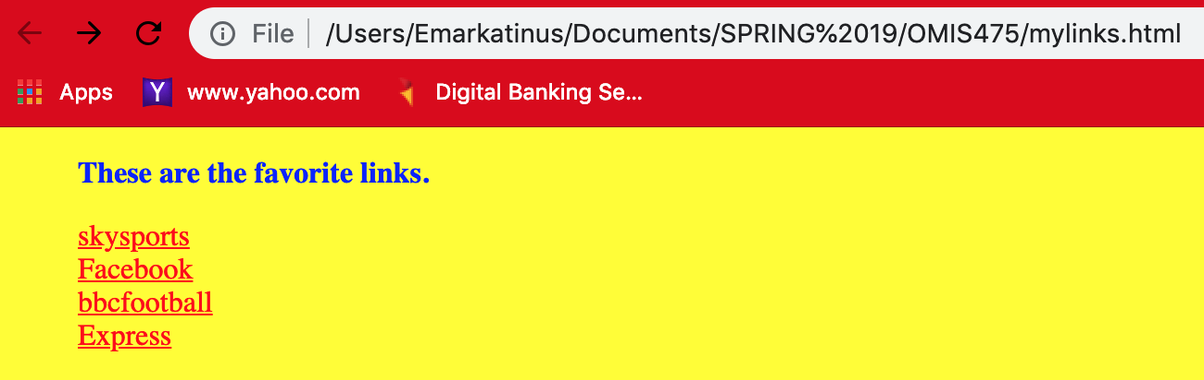

<!DOCTYPE html>

<html>

<head>

<title> Efetobo's Favorite Websites </title>

<link rel="stylesheet" href="links.css">

</head>

<body>

<ul>

<p style="font-weight: bold"> These are the favorite links.</p>

<li><a href="https://www.skysports.com">skysports</a></li>

<li><a href="https://www.Facebook.com">Facebook</a></li>

<li><a href="https://www.bbc.com/football">bbcfootball</a></li>

<li><a href="https://www.Express.com">Express</a></li>

</ul>

</body>

</html>

Links.css

body {

background-color: yellow;

color: blue

}

a:hover {

text-decoration: none;

padding: 11px;

color: blue;

}

a:visited {

text-decoration: none;

color: red;

}

a:link {

color: black;

}

ul {

list-style: none;

}